**Ragamufin-clothing**

Alteration

SLEEVES AND HEMS SHORTHEND OR LENGTHEND FEE £4-15

COATS, JACKETS, AND SKIRTS RELINED FEE £10-25

JACKETS AND TROUSERS RESTYLED & TAILORED FEE £10-20

DESIGNING TO CUSTOMER SPECIFICATION FEE £45-100

NEW ZIPS FOR TROUSERS, JEANS SKIRTS, & JACKETS FEE £5-25

NEW POCKETS IN ALL GARMENTS FEE £10-25

NEW SET OF BUTTON & BUTTON HOLES FEE £5-15

DRESSES, SKIRTS, & COATS ALTERED FEE £10-30

CURTAIN ALTERED AND REPAIRED FEE £10-25

FABRIC & PATTERN SUPPLIED BY CUSTOMER (TO MAKE) FEE £20-110

TAILORING

TROUSERS LEATHER £95-150 WOOL £60-95 COTTON £45-60 SILK £60-125

BOXER SHORTS COTTON £10-30 SILK £45-60

JACKETS LEATHER £95-800 WOOL £80-400 COTTON £25-95 SILK £70-480

WAIST COAT LEATHER £50-130 WOOL £35-100 COTTON £20-65 SILK £65-460

COAT LEATHER £95-950 WOOL £90-500 COTTON £60-350 SILK £90-400

SHIRT LEATHER £70-200 COTTON £15-60 SILK £60-140

SKIRT/MINI LEATHER £45-90 WOOL £25-60 COTTON £15-45 SILK £45-100

SKIRT/KNEE LEATHER £60-120 WOOL £50-90 COTTON £30-60 SILK £75-130

SKIRT/FULL LEATHER £95-200 WOOL £90-160 COTTON £60-90 SILK £80-160

BLOUSE LEATHER £60-130 COTTON £30-100 SILK £45-200

DRESS/SHORT LEATHER £100-200 WOOL £65-130 COTTON £35-80 SILK £50-150

DRESS/FULL LEATHER £95-350 WOOL £60-200 COTTON £35-110 SILK £80-250

SEQUIN GARMENTS £95-1000

CURTAIN MADE DRALON £95-700 COTTON £60-375 VELVET £100-1000

**OTHER SERVICES**

BASIC COMPUTER REPAIR AND INSTALLIONS £15.00 PER HOUR

BASIC PAINTING & DECORATING RING OR EMAIL FOR QUOTE

C:\Users\MICHAEL\AppData\Local\Microsoft\Windows\Temporary Internet Files\Content.IE5\QV2WGQPZ\MM900336677[1].gif*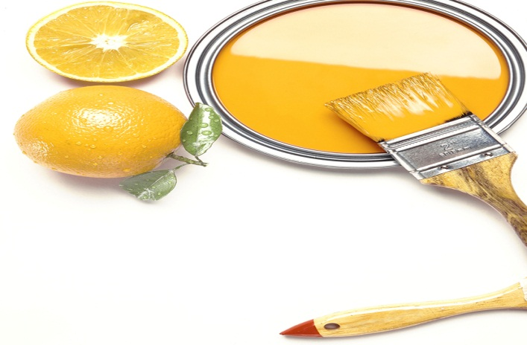C:\Users\MICHAEL\AppData\Local\Microsoft\Windows\Temporary Internet Files\Content.IE5\YQZFDN9K\MC900018331[1].wmf*

COMPANY YOU CAN TRUST